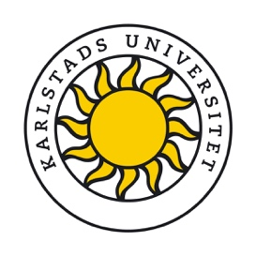

28 August 2024

# Information about the processing of personal data

When applying for priority right to re-employment at Karlstad University, or priority right to increased working hours, we process your personal data such as name, contact details, qualifications and other personal data that you enter in our recruitment tool when you register your application. The purpose of processing your personal data is for Karlstad University to be able to administer your application. The processing of personal data is part of Karlstad University’s exercise of public authority as well as on the basis of carrying out a task in the interest of the public. Your data is preserved in accordance with applicable legislation. If you are employed at Karlstad University, your data is archived in connection with your appointment.

Karlstad University uses the recruitment tool Varbi. When you apply for priority right via the recruitment tool, Karlstad University is the data controller of the processing of the data you submit in your application, and Varbi AB is the data processor. When you create a Varbi account, Varbi AB is the data controller for the data you register in your personal account.

Remember that Karlstad University is a government agency, which means that when you submit your application, it becomes a public document which is registered and will be disclosed upon request if the information included in your application is not covered by confidentiality. As a general rule, information included job applications is not covered by confidentiality.

Also remember not to register more personal data than is necessary to apply for priority right and avoid registering sensitive personal data. Examples of such data are ethnic background, sexual orientation, political views, health-related data, religious beliefs or trade union affiliation.

If you have any thoughts or questions regarding how we process your personal data, you are welcome to contact the HR Office or the HR specialist you have been in contact with.  
[HR Office](https://www.kau.se/om-universitetet/organisation/var-verksamhet/centrala-stodfunktioner/hr-avdelningen)

Information about how Karlstad University processes personal data and your rights:   
[Processing of personal data at Karlstad University – Privacy protection policy](https://www.kau.se/en/about-university/contact/about-kause/contact-webmaster/processing-personal-data-karlstad-university)

Information about how Varbi AB processes your personal data in the recruitment process (in Swedish): [Personuppgiftsbehandling vid Varbi AB - Dataskyddspolicy](https://profile.varbi.com/info/memberterms/modal:1/)